Accessing EC2 Using SSM Session Manager

- We can connect to a public or private EC2 instance via SSM Session manager without SSH connect , STS , no need of port 22 and CLI command on AWS console.
- We can attach IAM role (AmozoneSSMManagedInstanceCore) along with permission to EC2 instance to enable SSM connect .
- EC2 instance should have SSM agent installed . bydfault the agent will be installed to server once you attach the role before server creation or we can configure after server creation.
- In SG https (443) should be enabled.
- SSM Session Manager service is not comes under VPC . This is outside of service.
- We can use this service along with any one of the given service IGW , NAT and VPC end point.
- We can also configure SSM in our local system . mind the flow.
- Request by client -
Client request for connection -> SSM Session Manager ->IGW/NAT/VPC endpoint -> Subnet -> EC2 instance outbound rule (SG) ->EC2 instance .
- Response from Ec2 instance –
EC2 instance-> EC2 instance outbound rule (SG)-> IGW/NAT/VPC endpoint-> SSM Session Manager-> Client system

Task -1 ( We can perfom this task with IG/NAT/endpoint .but here we implementing with IGW)
- Create a server and connect the server on AWS console using SSM Session Manager . (here we are attaching IAM role after server creation).
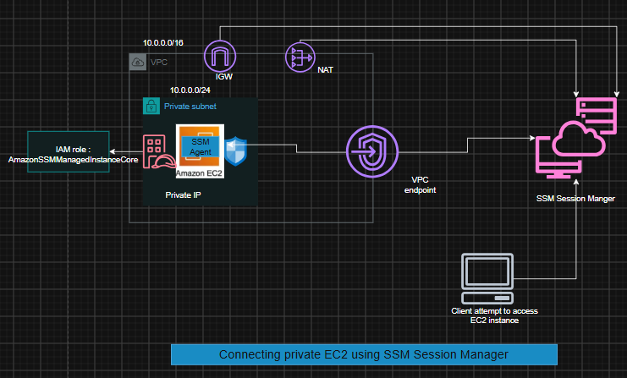

Prerequisite-
1.Ec2 Instance
2.SG with Http port enabled
3.IAM role including (AmozoneSSMManagedInstanceCore) permission.

Steps-
1.Create an instance .[Make sure attached SG ,Outboundrule should include https (443 port )]
2.Create IAM role and add permission(AmozoneSSMManagedInstanceCore) .
3. Attach the permission to EC2 instance .
4.Try to connect the server

Implementation-
1.create a server name Test-SSM-Connect
Make sure enabling public ip
And do not choose any key
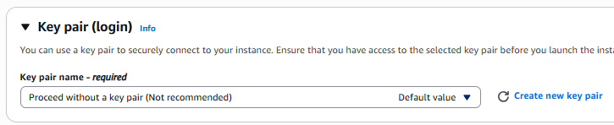
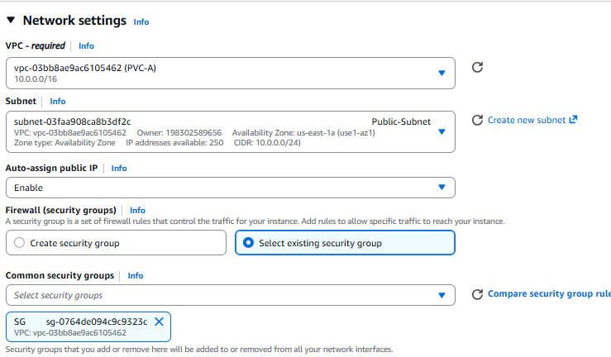
Note - We can enable or disable public ip since we have not given any key . it wont help in connecting server with the help of SSH Clint

Server created
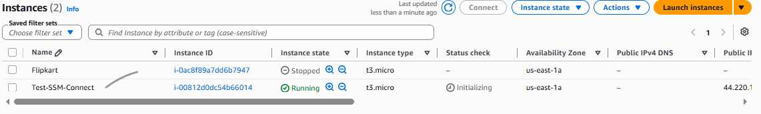
We should get this output 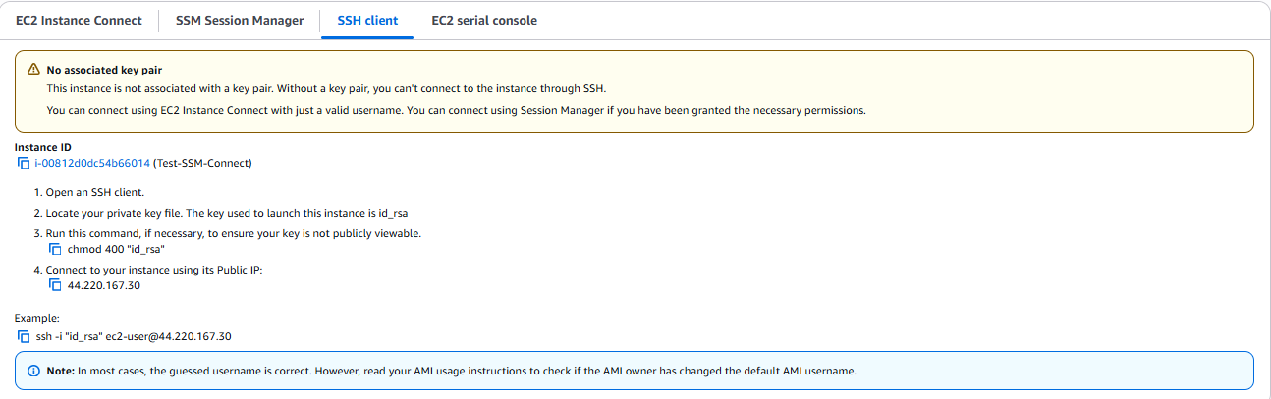

2.Now Create IAM role and add permission(AmozoneSSMManagedInstanceCore) .
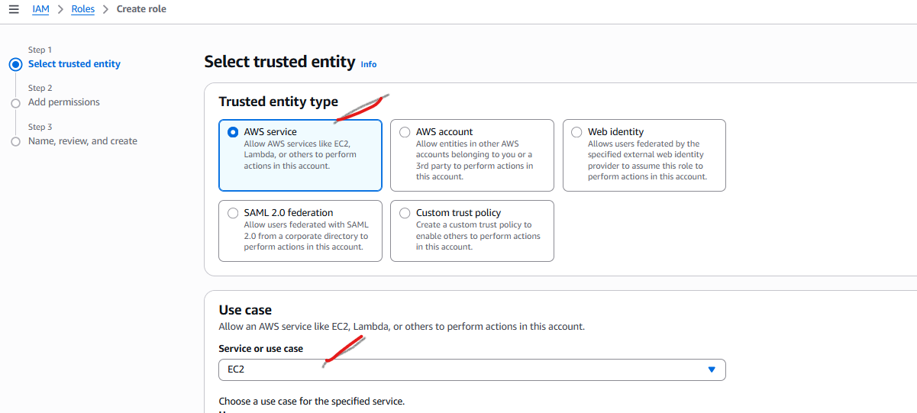
Select Permission - AmozoneSSMManagedInstanceCore
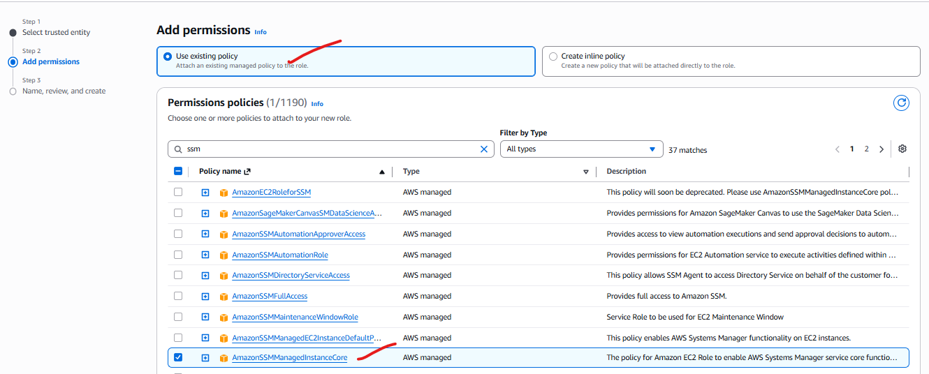
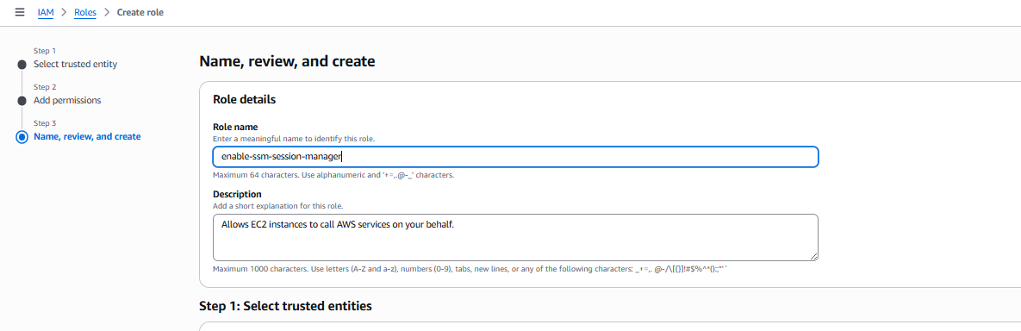

3. Attach the enable-ssm-session-manager role to EC2 instance (Test-SSM-Connect).

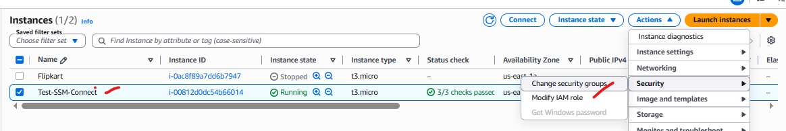
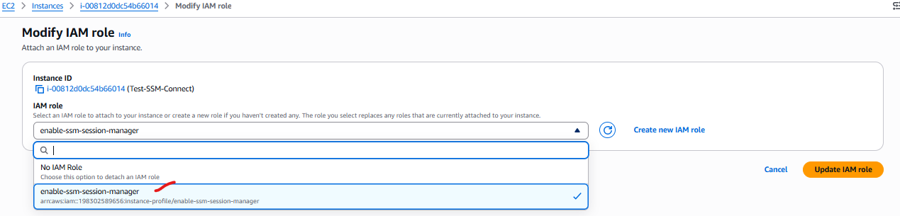

*Note – We can attach the IAM role during the server creation steps.
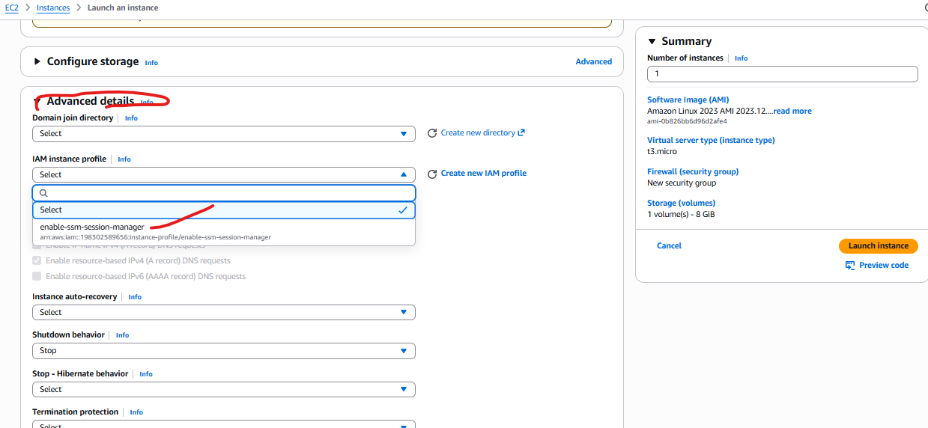

4.Try to connect the server
It will take some time to configure then only will able to show the connect option.
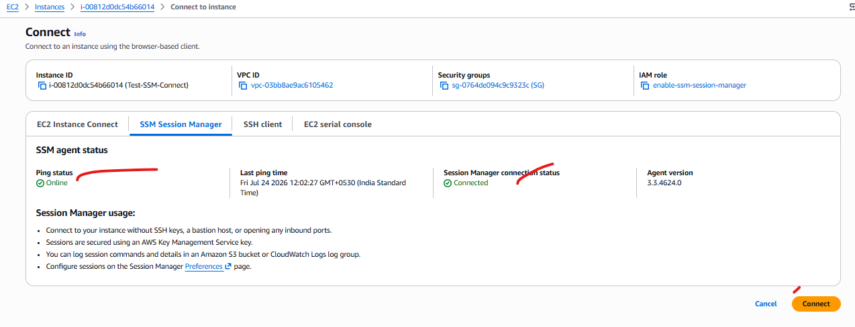

It will show a terminal window , there you need to give command sudo su – to enter the root directory.
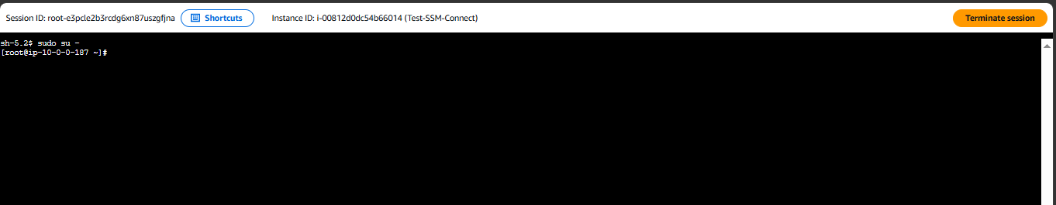
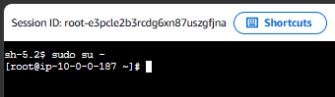

Like this way we can connect with server using IGW(with public/pvt ip) , NAT ,VPC endpoint and custom VPC endpoint.

We can configure Session manager in our local machine using following steps –
1 .First configure aws CLI with aws access key and access secrete key .
2. Use aws configure command.

- winget install Amazon.SessionManagerPlugin

Note* - sometime even after installation the PATH is not set in Environment Variable . We need to check installation by -> session-manager-plugin
And then get the path > Get-Command session-manager-plugin
Then add the path to environment

aws ssm describe-instance-information
aws ssm start-session --target i-086b536e26738c02b
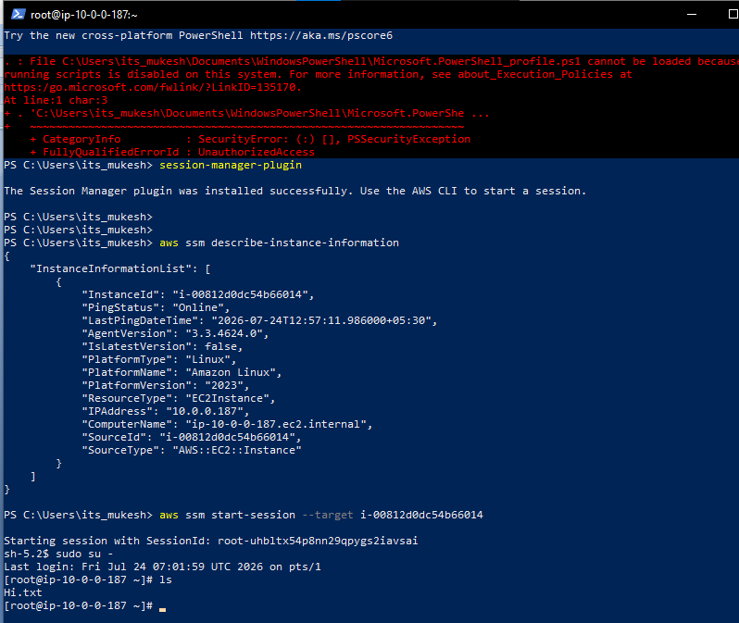

Task Over

